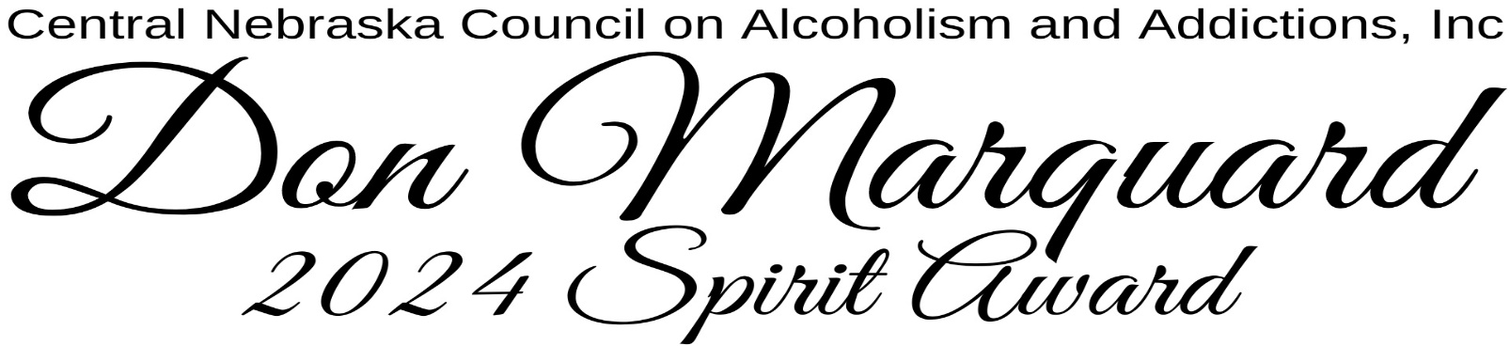
This Award is given in memory of and pay tribute to Don Marquard, who founded the Central Nebraska Council on Alcoholism in 1967, together with a large group of caring individuals who wanted to help individuals and families struggling with alcoholism. With this Award, we recognize, honor, and give our most sincere thanks to a person who exemplifies the character, values, and integrity of our founder, Don Marquard, who had an incredible passion for helping others, supported recovery, and offered HOPE to so many.
Each nominee will receive a congratulatory letter and one (1) complimentary ticket to the
April 18th Dinner/Comedy Show where the award recipient will be announced. Additional tickets for
family and friends may be purchased for $53 each or $400 for a table of eight (8).

Who was Don Marquard??? Below is “A Tribute to Donald C. Marquard” …….

A Summary taken from, A Tribute to Donald C. Marquard | memorial officiant unknown
"We remember a man whose changed life illustrates how other lives are influenced and changed. I am permitted by the family today to be very frank about one important fact: Don Marquard was a recovering alcoholic. Once an alcoholic, always an alcoholic. In other words, an alcoholic can never take one drink without the possibility of trouble. Don came to know this through Alcoholics Anonymous. For twenty-seven years, he had known complete and continuous sobriety. He was able to do this because he followed the Twelve Steps of A.A. Don became an advocate to help others who were suffering from alcoholism. He did it in person to person contact with alcoholics and their families. He was a warm spirited person, honest with himself and others, and willing to help others who wanted help. He became certified in the field of alcoholism at Columbia University, the University of Wisconsin, the University of Nebraska, and Kearney State College. He became a well-known and loyal member of A.A., attending regional and national meetings and sometimes called to speak on this theme. For twenty-two years or longer, he continued as a counselor to alcoholics and families. He and Mrs. Marquard started the first Alateen in Grand Island. In 1966, Don’s dream to provide a program to help alcoholics began to take shape. In that summer about fifty businessmen in Grand Island began to meet to think about what could be done to help scores of persons, hundreds of persons in need because of alcoholism. They thought of the formation of an information and referral center, they dreamed of more facilities for A.A. meetings reaching out to so many affected by alcoholism. From this group came the board of directors of the Central Nebraska Council on Alcoholism (CNCA). Progress was slow and money did not come easily, but on April 17, 1967, offices were secured in downtown Grand Island and a program of service and information and counseling began. It continues to this day, touching the lives of thousands of persons in Grand Island and surrounding territory. The movement of information, education, and counseling has grown in many ways. From one A.A. meeting held down in the basement of the Yancy Hotel, there are now many meetings held each week, held in churches and other institutions. There are Alanon meetings for spouses of alcoholics. There are meetings of Alateen for teenage children of alcoholics. Other improvements have been made to help persons and the community face up to the reality of alcoholism and the help so many persons and families need. Of course, scores of men and women in this community have pitched in to help this program of service and education become a reality (Thank God for them). But most would agree that Don Marquard has been in the forefront all the way. Not only has he continued to be a good neighbor in face to face relationships, he has been a good neighbor in helping to expand the program so that increasing numbers of persons may be helped."

Nomination form on next page…….
2024 Don Marquard Spirit Award Nomination Form
Do you know someone who exemplifies the character, values, and integrity of our founder, Don Marquard, who had a passion for helping others and supporting recovery?
Must submit one nominee at a time; current CNCAA board members and staff are not eligible for this nomination.
Nomination forms can be found at https://form.jotform.com/yagersandralee/2024SpiritAwardNomination
or complete this form and email to Connie@cncaa.net. Nominations will be reviewed and the winner selected by an anonymous ad-hoc committee.

- Nominee's first and last name _________________________________________

- Nominee's email address: ____________________________________________

- Nominee's FULL physical address:
_________________________________________________________________

City: ________________ State: _____ Zip Code:_______________

- Your first and last name: _____________________________________________

- Your email address: _________________________________________________

- Your relationship to the person you are nominating: __________________________________________________________________

- Please explain on a separate sheet of paper how the person you are nominating for this award exemplifies the character, values, and integrity of our founder, Don Marquard, who had a passion for helping others and supporting recovery?

- Please provide any additional information to support your nomination.

Thank you!!

Deadline is March 25, 2024 by 5:00pm Central Time
Please email nomination to Connie@cncaa.net

