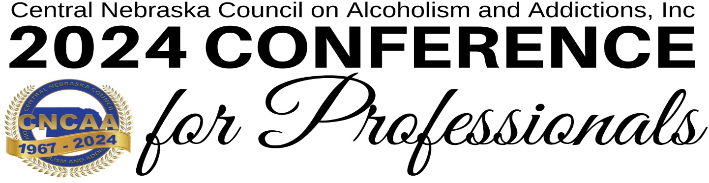

Exhibitor Booth Registration Registration Deadline: Friday, April 5, 2024

Organization Name: ________________________________________________________________________________ Address: _________________________________________________________________________________________
City: __________________________________________________________ State: __________ Zip: _______________
Main Contact: ________________________________________ Title: ________________________________________ Phone: ________________________________ Email: ____________________________________________________

 |  | Not for Profit Pricing | For Profit Pricing
April 18 Only | Exhibit Booth Only (includes 6’ table and table cloth) Does not include attendance at Conference. | $100 | $225 | $_________
April 19 Only | Exhibit Booth Only (includes 6’ table and table cloth) Does not include attendance at Conference. | $100 | $225 | $_________
April 18 & 19 | Exhibit Booth Only -- Save $25 (includes 6’ table and table cloth) Does not include attendance at Conference. | $175 | $425 | $_________
April 18  Workshop | Bob Tyler  “Clinical Tools for Treating Substance Use Disorder” | $186 x ____ attendee(s) = _____________
April 19 Workshop | James Campbell  “Helping Build Recovery Capital in Those We Serve” | $186 x ____ attendee(s) = _____________
April 18-19 Workshops | Both Workshops | $360 x ___ attendee(s) = _____________
Dinner-Comedy Show | Thursday, April 18  Ally Weinhold = “Laughter is Good Medicine” | $53 x ___ attendee(s) = _____________
Both Workshops & Dinner Comedy Show | Thursday & Friday, April 18 & 19 plus Dinner/Comedy Show (Save $25) | $400 x ___ attendee(s) = _____________

Total $__________
Contact Information for Additional Attendee Conference Registrations
Name: ________________________ Title: ____________________________ Email: __________________________ Name: ________________________ Title: ____________________________ Email: __________________________ Name: ________________________ Title: ____________________________ Email: __________________________ Name: _________________________ Title: _____________________________ Email: ___________________________

*Not-For-Profits: Please attach a current copy of the IRS Affirmation or Determination Letter issued to your organization.

Description of Sponsor Exhibit (materials/equipment you intend to display)
________________________________________________________________________________________________________________________________________________________________________________________________________________________________________________________________________________________________________________________________________________
All exhibitors are asked to provide a raffle basket valued at no less than $50.00 for the Dinner & Comedy Show. *Please do not include any form of alcohol, nicotine, THC, or CBD product. Booths will be closed during the Dinner/Comedy Show.
Theme of your complimentary raffle basket: ________________________________________________________

Payment Information: Total from page 1 = $______________

Check • Credit Card (Visa or MasterCard ONLY)
Name on Card: _______________________________________________________________________________
Card # ______________________________________________________________________________________
Expiration Date: _______________ 3-Digit Code: ____________ Billing Zip Code: _________________
Please do not email or fax completed form with payment information. If you would like to email, please leave payment info blank and call our office to provide payment. Phone: (308) 385-5520
Send completed form and payment to: CNCAA, 3204 College Street, Grand Island, NE 68803
Payment Policy. All payments must be received by Friday, April 12, 2024. The Central Nebraska Council on Alcoholism and Addictions, Inc. reserves the right to refuse admission if full payment is not received prior to the event.
Confirmation. A confirmation notification, including detailed information about set-up hours, where to ship materials, and other pertinent information will be sent via email to the contact person listed on the application several times before the conference.
Artwork & Graphics. Exhibitors must provide all artwork and graphics; for example logo, and advertisement
Questions? Contact Connie Holmes at 308-385-5520 or Email Connie@cncaa.net.
Force majeure: In the event CNCAA is prevented from carrying out its obligations as a result of any cause beyond its control, such as but not limited to acts of God, war, acts of terrorism, airline flight cancellations, strikes, lock-outs, flood, commercially unfeasible or failure of third parties to deliver goods or services, CNCAA shall be relieved of its obligations and liabilities for as long as fulfillment is prevented.

